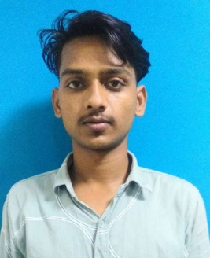



warisalisdgi@gmail.com

Waris Ali

Software Engineer

Self-motivated and hardworking seeking for an opportunity to work in a challenging environment to prove my skills and utilize my knowledge & intelligence in the growth of the organization.

7870972312



Noida sector 44, Noida/Delhi NCR U.P 201303, India

# SKILLS

CBASICAJ

**EDUCATION**

WORDPRESS

## B-tech

### Sunderdeep Engineering College, Ghaziabad

06/2019 - Present,­ Ghaziabad U.P

Pursuing B-tech 4th Year

Coomputer Science & Engineering From AKTU

## I.sc

### K.P.S College, Gaya

04/2017 - 03/2019, 67.04%

Courses

LEARNING PYTHON

Science (BSEB)

## Matriculation

HTML

BASIC C++

### Dini International School, Chakand Gaya

02/2016 - 03/2017, 83.6%

CBSE

# LANGUAGES

English

Professional Working Proﬁciency

Hindi

Native or Bilingual Proﬁciency

# INTERESTS

**WORK EXPERIENCE**

## Student

Fresher

# PROJECT

Airline Ticket Management

# CERTIFICATES

Software Developer

Software Testing

#### C and C++ certificate from Aptech Learning.

#### NPTEL Online certification from IIT Kanpur.

# DECLARATION

#### I here by declare that all the statements furnished in this format are true to the best of my knowledge.